Task 1:

Prime data analysis:

1. We could see the highest number of movies produced from 2008 to 2021 by the director Rajiv Chilaka and a total of 19 movies.
2. During analysis we could that the number of movies released is higher than the tv shows released in prime.

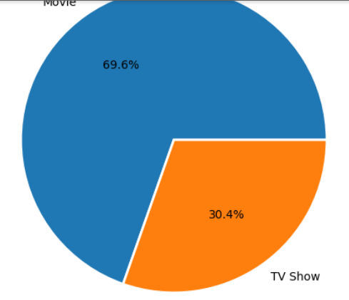

1. The highest-rated movie in the below years is “You Don't Mess with the Zohan” by the director Dennis Dugan with a rating UR.
2. We could see the movies and shows with a maximum duration of 113 and 103 min have the highest rating among all other time durations which means people like the movie that is not too long or short.
3. In the initial years the were very less amount of movies released and no tv shows,only after 2008 did shows where realize that to less compared with movies but after 2010 the release of both movies and tv shows are increased. This shows the exposure of Prime to people and movie makers is high.

1. According to the chart, the majority of movies on Amazon Prime are rated for viewers aged 13 and above. However, for TV shows, the ratings vary between '13+', '16+', or 'All'.

1. According to this data, the most common category available on Prime is international movies and TV shows are in less in amount. If Prime improves the amount of releasing tv shows the tv show audience will also increase.

1. The movie that has longest duration is black mirror Bandersnatch with the duration of around 300 mins and tv show with highest duration is Grey's anatomy with 16 episodes.
2. Based on the data, the top 2 countries that released the most TV shows and movies on Amazon Prime respectively were the United States.

